Restaurant Database to Adapt from Table Service to Delivery During COVID-19 Lockdown

Student Number: 20091471

Student Name: Cian Dunne

Date: 16th October, 2020

Module: Database

Table of Contents

Title Page Page 1

Table of Contents Page 2

Business Description Page 3

3.a Business Name

3.b Location

3.c Description of Business

3.d Major Functions

3.e Benefits of Implementing a Database

Enhanced ER Diagram Page 4

Logical Design Page 5

References Page 6

Business Description

**Business Name:** Pizzeria Amore

**Location:** In the Heart of the Dublin City Centre.

**Description of Business:** Pizzeria Amore - a high-class Italian restaurant, has been forced to change their business from table service to a delivery service to ensure they continue to function as a business during the COVID-19 Pandemic and on-and-off Lockdowns.

**Major Functions:** The Restaurant receives Orders by Telephones manned by the former Wait Staff. The Wait Staff takes the orders and passes them to the Chefs who cook the order using a variety of Ingredients. The completed orders are then collected by a Driver who then delivers it in their vehicle to the Household who ordered the Meal.

A single Household can submit 1 or more orders. One or more Households will interact with one or more Members of Staff via Telephone to submit the Order. At least 3 Staff will create the order - a member of the Wait Staff to take the order, at least One Chef to make the Order, a Driver to deliver the Order. An Order can consist of One or More Order Items, which can be from up to Three different Courses. Each Order is composed of One or more Ingredients. A Driver can deliver to One or more Households.

**Benefits of Implementing a Database:** As the Business is moving to a new Working Design, a Database system will allow them to fully understand how the new Model is functioning - tracking number of orders, determining which households order often (which they could use to give discounts or meal vouchers as rewards for loyal service/incentives to keep ordering further down the line). Furthermore, it allows the Business to keep accurate records of stock usage to help with ordering from their suppliers. It also tracks which staff is performing what functions which allows for an easy method of determining the level of productivity the staff are working at, which may be taken into account when determining Holiday Bonuses or a potential Pay Rise during a Performance Review.

Enhanced ER diagram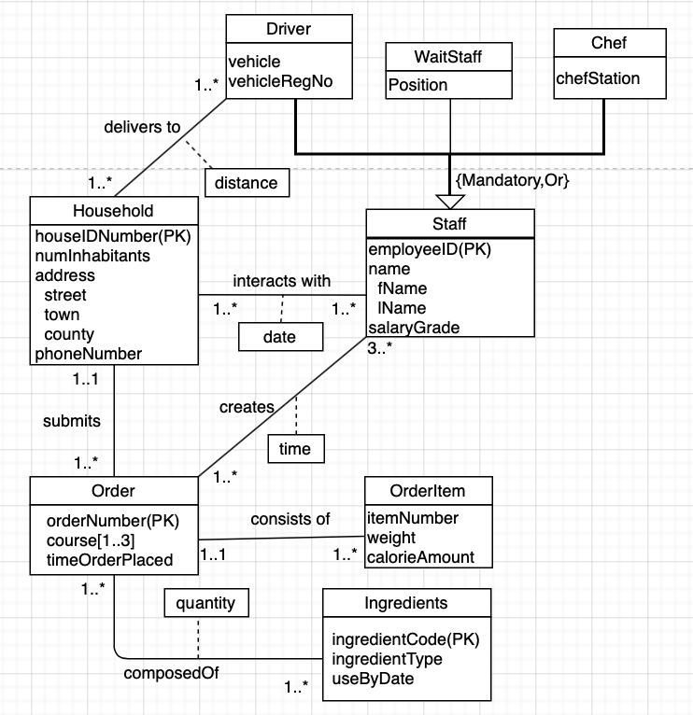

**Fig 1.1 Enhanced ER diagram Demonstrating the Databases Entities and Relationships**

Logical Design

Household(houseIDNumber, numInhabitants, street, town, county, phoneNumber)

Primary Key houseIDNumber

Order(orderNumber, timeOrderPlaced, houseIDNumber)

Primary Key orderNumber

Foreign Key houseIDNumber references Household(houseIDNumber)

OrderCourse(orderNumber, course)

Primary Key orderNumber, course

Foreign Key orderNumber references Order(orderNumber)

OrderItem(orderNumber, itemNumber, weight, calorieAmount)

Primary Key orderNumber, itemNumber

Foreign Key orderNumber references Order(orderNumber)

Ingredients(ingredientCode, ingredientType, useByDate)

Primary Key ingredientCode

Chef(employeeID, fName, lName, salaryGrade, chefStation)

Primary Key employeeID

WaitStaff(employeeID, fName, lName, salaryGrade, position)

Primary Key employeeID

Driver(employeeID, fName, lName, salaryGrade, vehicle, vehicleRegNo)

Primary Key employeeID

interactsWith(houseIDNumber, employeeID, date)

Primary Key houseIDNumber, employeeID

Foreign Key houseIDNumber references Household(houseIDNumber)

Foreign Key employeeID references Staff(employeeID)

creates(orderNumber, employeeID, time)

Primary Key orderNumber, employeeID

Foreign Key orderNumber references Order(orderNumber)

Foreign Key employeeID references Staff(employeeID)

composedOf(orderNumber, ingredientCode, quantity)

Primary Key orderNumber, ingredientCode

Foreign Key orderNumber references Order(orderNumber)

Foreign Key ingredientCode references Ingredients(ingredientCode)

deliversTo(employeeID, houseIDNumber, distance)

Primary Key employeeID, houseIDNumber

Foreign Key employeeID references Staff(employeeID)

Foreign Key houseIDNumber references Household(houseIDNumber)

References

1. 5 Tips for Wearing a Mask in a Restaurant | Eat This Not That. [ONLINE] Available at <https://www.eatthis.com/mask-tips-in-restaurant/>. Accessed [12th October 2020].
2. Database Assignment 1 Restaurant Delivery Finished-5.drawio - [diagrams.net](http://diagrams.net). [ONLINE] Available at <https://app.diagrams.net>. Accessed [8th October 2020].